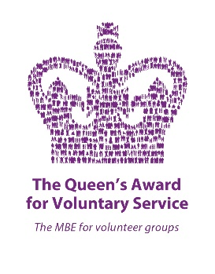
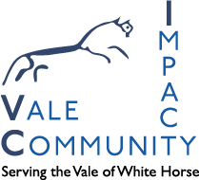

Wantage & Grove
Energy Support Fund
Please note this fund is only open to residents who live in the OX12 area, within 5 miles of Wantage.
This is a local fund set up to help local residents with the Cost of Living Crisis
Vale Community Impact will assess the applications for this fund.
If you are experiencing hardship as a result of the energy crisis and would like to be considered for help from this fund please complete this form and either email it to help@vci.org.uk or post it to VCI, 16 Market Place, Wantage OX12 8AE
If you have any trouble completing the form please call 01235 765348
Date:
Name:
Address: Post code:
Contact number:
Email Address:
Date of Birth:
Number of people in the household Adults: Children:
Please give us a brief explanation of your energy situation:

If you are not already a VCI client please attach proof of identity and address. This could be a copy of your driving licence or your passport and an official document with your name and address on.
Please be aware that there will be a high demand for this fund. The applications will be assessed on a first come, first served basis and the process could take up to five to ten working days. Once the decision has been made there will not be any right of appeal.

